***RPA Design and Development Course: Lab Exercise Manual v1.1***

**OBJECTIVE:** Step by Step guide explaining how to download and install UiPath Studio.

Step 1: Click on the link given here: <https://www.uipath.com/rpa/academic-alliance/academic-studio-download>

Step 2: Fill in your contact details and choose the institution you belong to. You will receive a link to download the software by email.

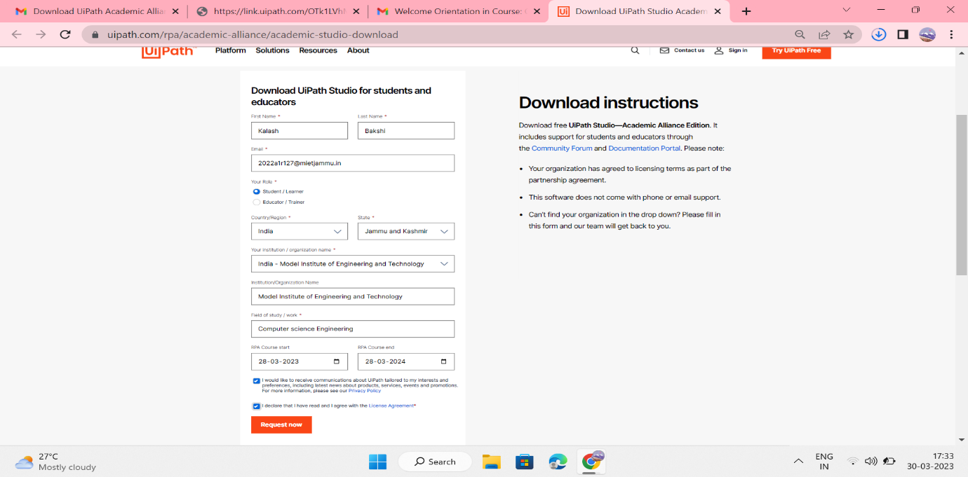

Step 3: Then, check your email. The email you receive contains the link to download the UiPathStudio.msi file along with your dedicated license key. Click either the orange button or the first link.

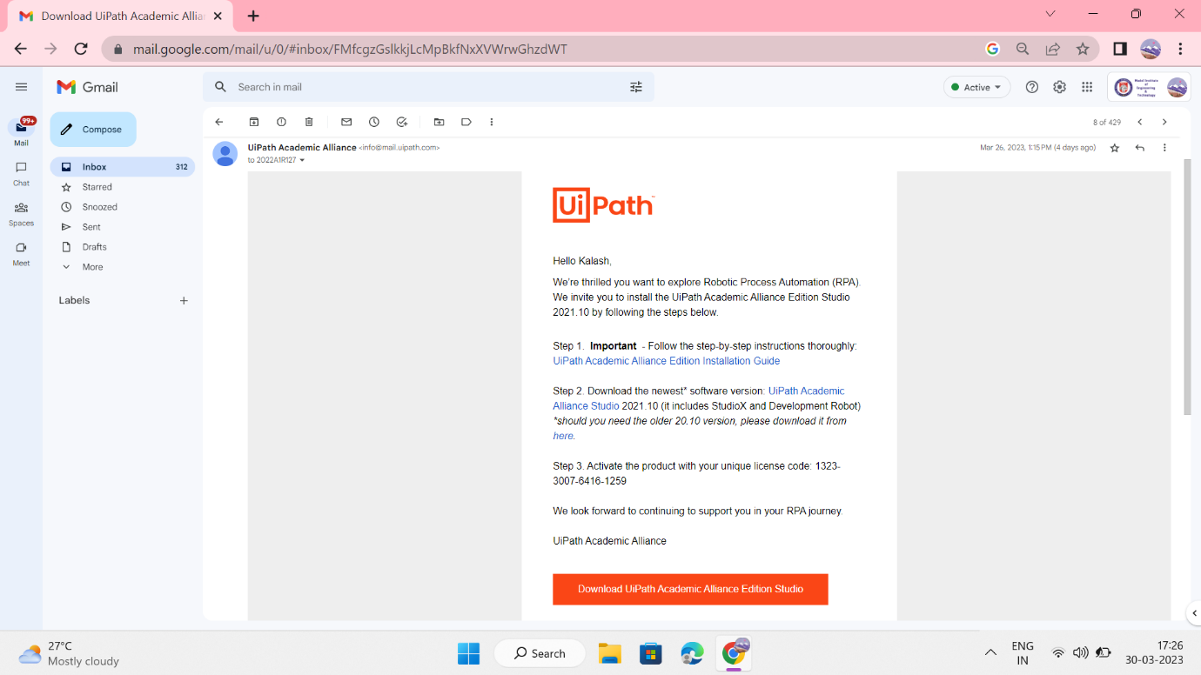

Step 4: The file will begin downloading. Click to open the UiPathStudio.msi once it is downloaded.



Step 5: click on install

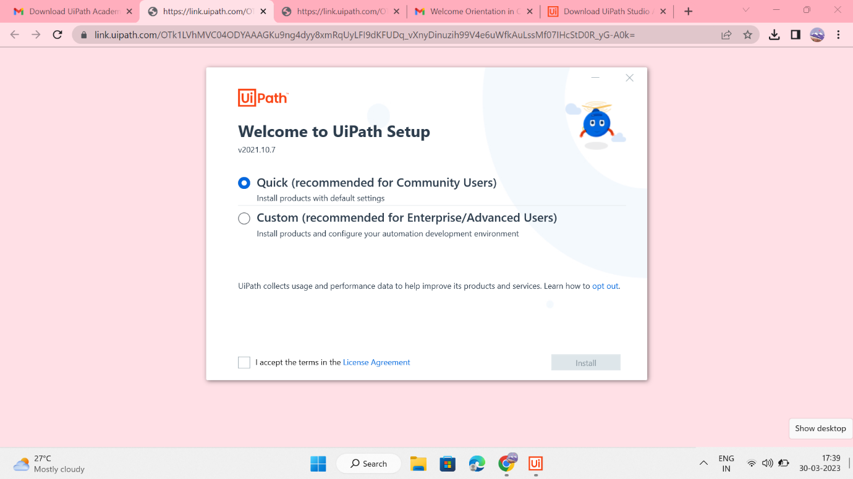Step 6 : After installation is complete, click on Launch UiPath Studio.

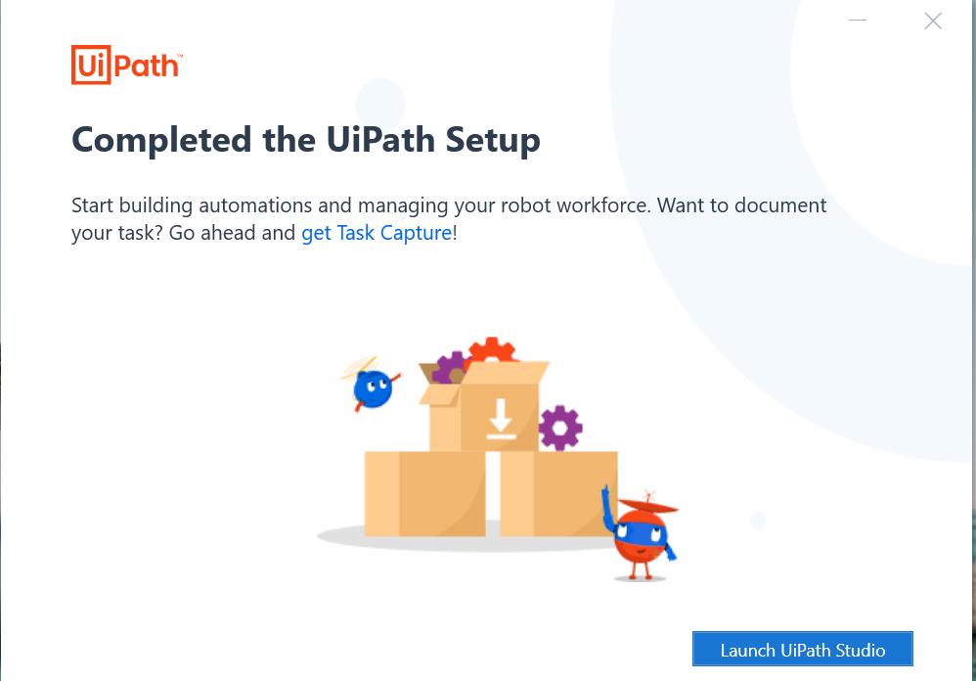

Step7) Enter the license key you received through your mail. 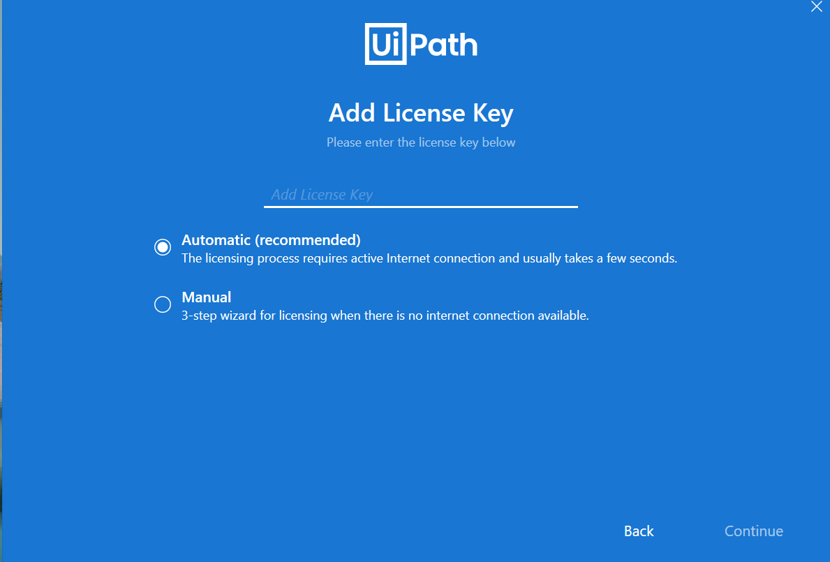

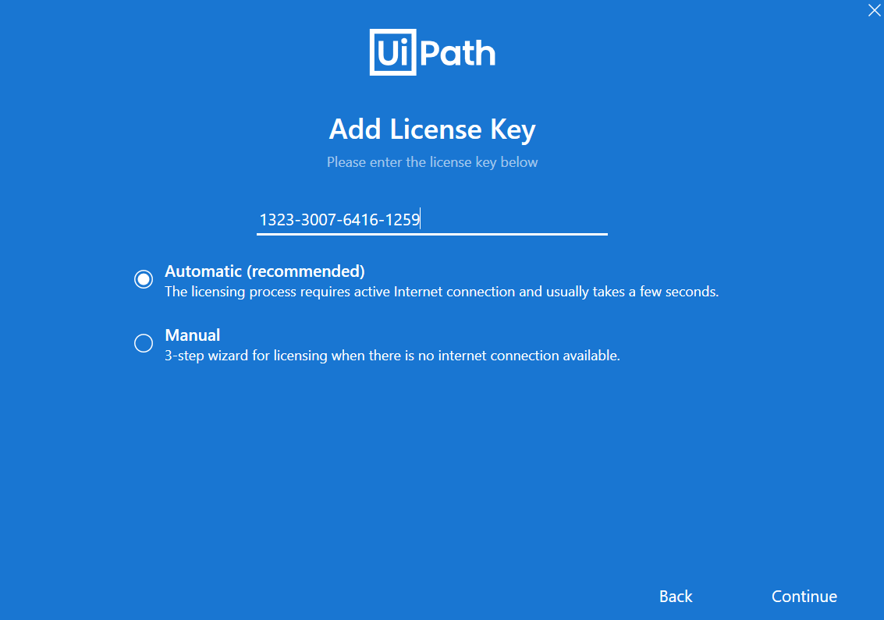

Step8) Now, you can start using UiPath software to create automation automation workflow.

